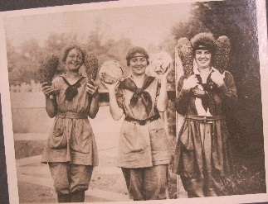
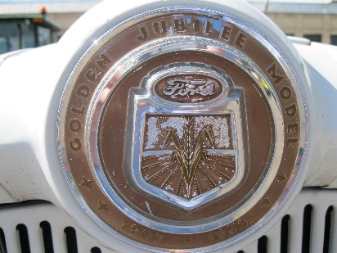
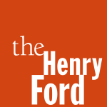
MOMCC
2018 Fall Conference
Call for Sessions &Workshops
The Henry Ford, Dearborn, Michigan
November 8-10, 2018

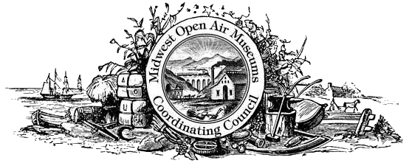

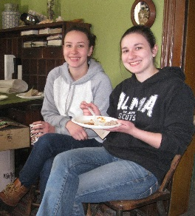
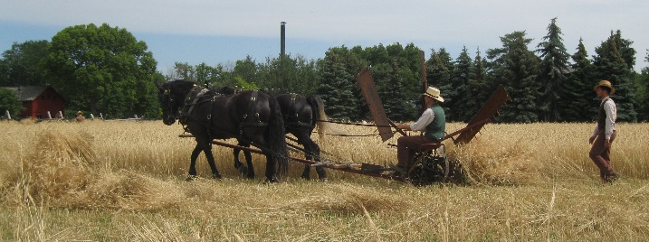

Tried and True
Reviewing ~~ Refining ~~ Improving

Join us at MOMCC’s 40th anniversary conference at The Henry Ford (THF). MOMCC began in the afterglow of the Bicentennial, and grew during the culture wars. Does MOMCC remain an organization relevant to its constituents? Help us set the course for the next decade. Workshop & selected sessions already proposed follow. After Thursday workshops attendees will gather for an evening in Eagle Tavern at Greenfield Village. Founding mothers and fathers will share their rational for creating MOMCC, and newcomers will counter with what they can do for MOMCC. The more the merrier at this exploration of open air museums in the 21st century.

• Practical hints and how-tos of draft horse management & harness care in public venues
- Pick your cooking workshop: hearths; woodstoves; coal stoves
• Build-your-own workshop with THF collections in the Benson Ford Research Center
• Tour of Detroit churches and stained glass with relatives of architects and designers
• Tour Ford’s River Rouge plant; see a new industrial environment
- Saying what you mean in 60 words and 400 characters; Amazing Archives
• Public engagement with American textiles in the Midwest with THF’s Jeanine Head Miller
• Finding those nuggets to create vignettes with THF curator & events guru Jim Johnson
• Hints about going local with your own Innovation Nation shared by THF’s Saige Jedele
- Giving up the Helm: Multi-Generational Leadership with MI preservationist Mallory Bower
- George W. Carver in Iowa: New ways to teach Carver; Nature Studies & Museum Ed
- Visitor Studies – how to ask aspirational questions; and what to do with your findings
- Making meaningful programs around historic crops, food ways, crafts, and historical techniques? Share your story with MOMCC friends.
Session proposals should be submitted not later than August 1, 2018
Submit to Debra A. Reid, Curator, The Henry Ford, 20900 Oakwood Blvd, Dearborn, MI 48124
debrar@thehenryford.org Phone (313) 982-6118

Call for Proposals
Workshops, Sessions, Panels, and Presentations

The Midwest Open Air Museums Coordinating Council seeks proposals for workshops, sessions, and presentations for the 2018 Fall Conference in Dearborn, Michigan. Half and full day workshops will be held November 8 and sessions on November 9 and 10. To submit a proposal, please ﬁll out this form attaching additional pages, if necessary. (E-mail is the preferred submission method.) All presenters must register for the full conference or day on which they present.
Proposal Deadline: August 1, 2018

Title of Session:

Description: (overview of content, goals, application)

Format (mark one):
__ Presentation __ Panel/Roundtable Discussion __ Performance/Demonstration
__ Thursday Workshop __ Other (please explain) ___________________________

Length: ___ 45 min __ 75 min session __ 3 hour workshop __ 6 hour workshop

Cost Per Person and minimum /maximum participants (for workshops only): _____
Indoor or Outdoor: ____________________ Space Size needed__________________________
A/V Needs: ________________ Will You Be Using a PowerPoint or similar? Y __ N __
Special/ Additional Needs:

Session Leader Name and Position:
Afﬁliation:
Address:
Email Address:
Phone : Fax :

Additional Participants: (please provide same information as session leader for each additional participant, attach additional sheets, if necessary): ____________________________________

Contact a Board member or the planning committee if you need assistance in finding suitable presenters.

SUBMIT TO:
Debra A. Reid, MOMCC 2018 Fall Program Chair
Curator, The Henry Ford, 20900 Oakwood Blvd., Dearborn, MI 48124
DebraR@thehenryford.org
phone: (313) 982-6118

